Wirral Primary Schools Cross Country Association – Cross Country Races for Wirral Primary Children

This race is due to be held on Thursday 2nd March 2023 in Arrowe Park. We use the field directly behind Arrowe Park Hospital, as indicated on the map below. The running order is Y4G, Y4B, Y5G, Y5B, Y6G, Y6B.  Points from last event:  - Bring as many participants as you like. It is about giving our children an opportunity.  - If your school did not win any medals, but you want a couple in order to sustain interest and reward tenacity, please ask Andy or Steve. We will gladly give you what you need.  - If a child turns up late and after their race has taken place, put them into the next suitable race (i.e put a Y4 into the Y5 race). Its better they run than go home without taking part.  Parking at Arrowe Park  The field we run on is equidistant between the Cherry Orchard car park and the Arrowe Brook car park as shown on the map below. Arrowe Park was recently made ‘Pay & Display’. Up to 1 hour is 50p, up to 2 hours is £1. There is free parking, albeit with a longer walk, on Thingwall Rd.  Map  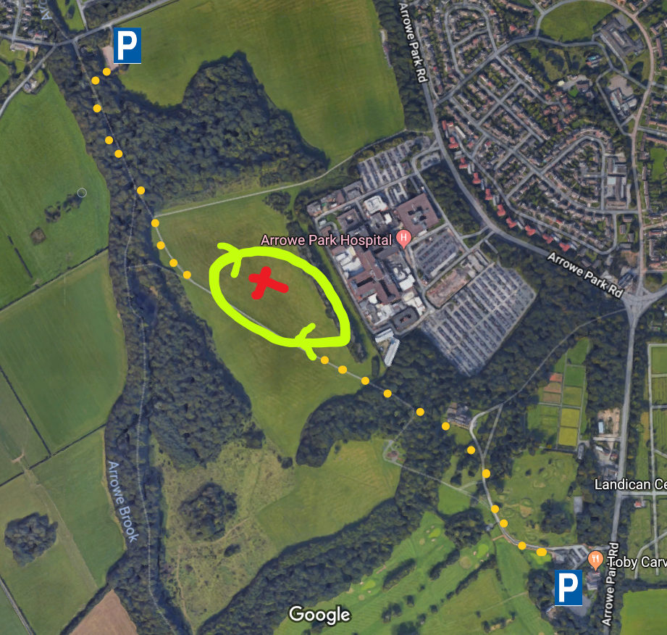 | COVID-19 Precautions:  All COVID-19 precautions are made clear on our COVID-19 Risk Assessment. This has been sent to schools by email, is on our website and has been shared on the WhatsApp group. It details precautions required for races to proceed.  Points of Note:  - First Aid  Each school is responsible for the first aid of their pupils at all race events, including minor cuts and grazes, breathing difficulties, administering medicines (i.e. inhalers), etc. Please note there are no toilets at any venue.  - Behaviour  It is each school's responsibility to ensure the behaviour of their children and spectators. Please be vigilant and ensure that no one obstructs the runners at any point, especially at the end when they may be waiting for their number.  - Spectators  Spectators must remain in designated areas at all times in light of covid restrictions. It is vital the risk is minimised by remaining in the designated areas to ensure minimal contact between groups. Please help reinforce this message to the spectators in your party.  - Public Parks  The area is a public open space, and Wirral Borough Council gives us permission to use it for our cross country events each year. Please help by keeping a close eye on your children at all times - don't let them wander off or try running around the course when they are not taking part. Take all your litter home and remind children to collect belongings.  Organisation of Races  - Races begin at 4.15pm and are completed with a presentation by approx 5.20pm. Except in exceptional circumstances, no race will be cancelled in advance and a final decision will be made at 4.15pm on the course. A information talk for all competitors will take place at 4.05pm. Children to remain in school bubbles for this time.  - Races are over two laps, in total, about 1200m on grass and path.  - No spikes or boots are to be worn.  - Each race meeting is an individual entity and a school may enter as many or as few races as they choose.  - There are six races at each meeting - Y4 girls, Y4 boys, Y5 girls, Y5 boys, Y6 girls, Y6 boys. There is no limit on numbers of pupils a school wishes to bring along.  - At the meeting each school will receive a results recording pack. There are two small results cards where you indicate your fastest 4 boys and fastest 4 girls positions overall. These are used to work out the winning teams. Please return these when asked for.  - Medals will be awarded to the first three individuals of each race. Medals will be awarded to the first six teams. No child shall win two medals at a meeting. If a child is in the first three and is a member of a winning team, then the team medal shall be passes down to another member of the team. Any child finishing in the positions four to ten who is not receiving a team medal will receive an individual medal.  - Scoring – At the end of a meeting your four best scores on your team cards will give your teams scores (boys team separate from the girls team). Team totals (for complete teams) are entered on a card and should be handed in at the end of the race. Results are not sent out to schools and are only announced during the presentation.

